IMC 446 Brand Planning and Message Strategy. Mid-Term
Upload to Blackboard when completed. There are 20 questions. You have three hours to finish the test. Please use your class notes, PowerPoint presentations, assignments, and the readings. No AI and No Google ( yes, I can tell).
When answering questions with video, please ignore pre-rolls.
(If you have any questions, email me at learle@roosevelt.edu. I am standing by.)

Liquid Death Case:
Much-lauded, death-themed canned water brand Liquid Death Mountain Water has built an incredible brand and a successful business by ripping up the playbook and borrowing from a completely different category.
Before Liquid Death’s foray into the market, water brands were almost indistinguishable: the same or mildly different plastic or glass bottles featuring pastel blue and pink logos, a holier-than-thou tone of voice, mountain peaks and trickling springs, fronted by impossibly good-looking athletes and fitspo models with impossibly hydrated skin.
Enter Liquid Death.
From its quirky, rebellious messaging to the brands it sponsors and the content it produces, it doesn’t feel like the brand should be in the same universe, let alone the same aisle, as Evian, Dasani, or the bland ocean of branded water competitors.
Instead, using an extremely bold marketing approach, Liquid Death drew inspiration from the heavy metal and punk rock aesthetic, targeting an entirely different segment of the market: young men who had previously only drunk water at the gym.
It seems obvious. If you want to sell to a group of people who haven’t been targeted before, take a category that successfully targets them and (respectfully) beg, borrow, and steal whatever you can.
Liquid Death has achieved this by targeting categories that traditionally appeal to young men, such as energy drinks, craft beer, and punk, and brilliantly repurposing a formula already proven to work. To give you a perspective of their marketing communication, watch this: https://www.youtube.com/watch?v=jYkKBXqqunE
Based solely on the information above about the Liquid Death Case, answer the following questions:
1. For Liquid Death - What is the product?
Natural Mountain water packed in same or mildly different plastic or glass bottles using similar background scenes and characters.
2. For Liquid Death - What is the brand?
The brand embraces a "death-themed" persona, drawing inspiration from heavy metal and punk rock aesthetics to craft a unique, rebellious message different then bland ocean of branded water competitors.
3. What would be the target’s age and sex?
Sex: Males
Age: 15-40
4. What would the psychographic factor of attitude be for this target?
Rebellious, non-conformists, appreciative of dark humor.
5. What would be a behavior factor for the new users’ target?
These new users fall into Switcher’s category who only drank water at gym or uses energy drinks, craft beer, and punk and will try the product out of curiosity, not just for hydration.
6. What is the positioning for Liquid Death in this brand content? (one line)
Liquid Death Mountain Water: Murder your thirst.
7. As discussed in class, is the purchase of Liquid Death limited or extended problem-solving?
Limited Problem-Solving.

8. Based on new users for Liquid Death, what would be the marketing objective? (Use the chart from class)

To increase sales by generating trial among young men who consumes energy drinks, craft beer, and punk.

9. Again, based on new users, what would be the communications objectives? (Use the chart from class.)

Generate awareness that Liquid Death is rebellious and punk rock source of hydration.

These questions are NOT based on Liquid Death.

10. Using the exact wording in the definition of IMC, why is this an example?
https://www.youtube.com/watch?v=RqGIemVf4cY
They utilized IMC to ensure their message for female runners was consistent across various channels, creating a unified brand experience to celebrate women’s strength and confidence.

11. State four criteria (that’s words, not an explanation) as to why this TV commercial would be considered ‘good or great.’ (List)

https://www.youtube.com/watch?v=GEPhLqwKo6g
- Relevant.
- Unexpected.
- Emotional.
- Simple.

12. What would be the value proposition for this Porsche Turbo S? (German manufacturer, achieves 0-60 mph in a mere 2.4 seconds, costs $285,000)? Identify and explain the three benefits.
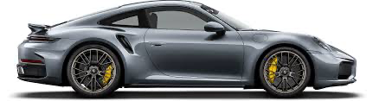

Rational Benefit: Exceptional Performance, and modern-edge German Technology.

Emotional Benefit: Psychological Satisfaction evoking superiority.

Self-Expressed Benefit: Elite status, and a passion for excellence.

13. One of the criteria for evaluating marketing communication is truth.
What is the truth in this commercial? (max three lines)
https://www.youtube.com/watch?v=XcbSCnUXOkk
Greatness isn’t just for few or the superstars; it’s something every one of us can achieve. It’s all about the effort we put in and how we define our own personal greatness and this is how Nike supports everyday movement towards better.

14. From what we discussed in class, what is a brand for a consumer?
(Circle or check the correct answer)
- A bunch of stuff in your head
- A logo
- Positioning
- Branding

What Did You Have for Breakfast Today?
QUESTIONS FOLLOW
Client/Brand: Kellogg's Nutri-Grain, Agency: Leo Burnett, USA
BACKGROUND
Nutri-Grain was the pioneer and leader in the cereal bar category. The first to introduce a tasty, convenient breakfast alternative, it was positioned as the perfect solution for those who don't have time for breakfast. Nutri-Grain slipped into this 'virtuous cycle' of success - taste, convenience, and nutrition.
Fast forward ten years ... Nutri-Grain was now in decline. In 2000, Nutri-Grain sales declined by nearly 10%, and the category as a whole was down 4%. The success cycle no longer seemed to work. What went wrong? The cereal bar category had been commoditized. Hoping to replicate Nutri-Grain's success, competitors, including Nabisco and Quaker, as well as smaller brands and store brands, jumped into the category. The new entrants failed to differentiate and adopted the same 'virtuous cycle' of functional benefits. As a result, any consumer emotion around this category dissipated. The category became a blur of interchangeable options, resulting in consumer indifference, and brands fighting for space in a shrinking category.
Quantitative further confirmed that our virtuous cycle had indeed become a vicious one. Nutri-Grain was stuck in an endless loop of the functional. The brand was perceived as a mere tasty convenience, along with the rest of the lot. The strategic platform on which this brand was established was no longer compelling or unique.
Sales had become stagnant, and in some instances, they were even down.
SEGMENT TO TARGET
Our business was with "Breakfast Believers". They strongly believe in the age-old saying, "Breakfast is the most important meal of the day!"
Despite best intentions, hectic mornings get in the way. As people in a hurry tend to do, they sometimes make bad decisions. Breakfast gets reprioritized. Faced with the dilemma between eating right and getting out the door on time, they leave home hungry and have to fend for themselves. Once on the run, they reach for a myriad of seemingly innocent, but bad-for-you impulse alternatives like donuts, bear claws, and bagels.
The opportunity became clear. If we could get them to choose Nutri-Grain in the morning, they wouldn't suffer the consequences of bad food choices.
INSIGHT: Hectic mornings make people more susceptible to poor food choices.
BRAND IDEA: Choose Nutri-Grain & avoid the consequences of bad morning foods.

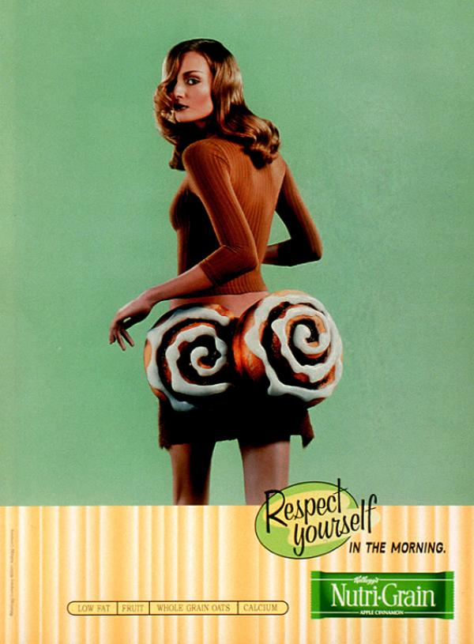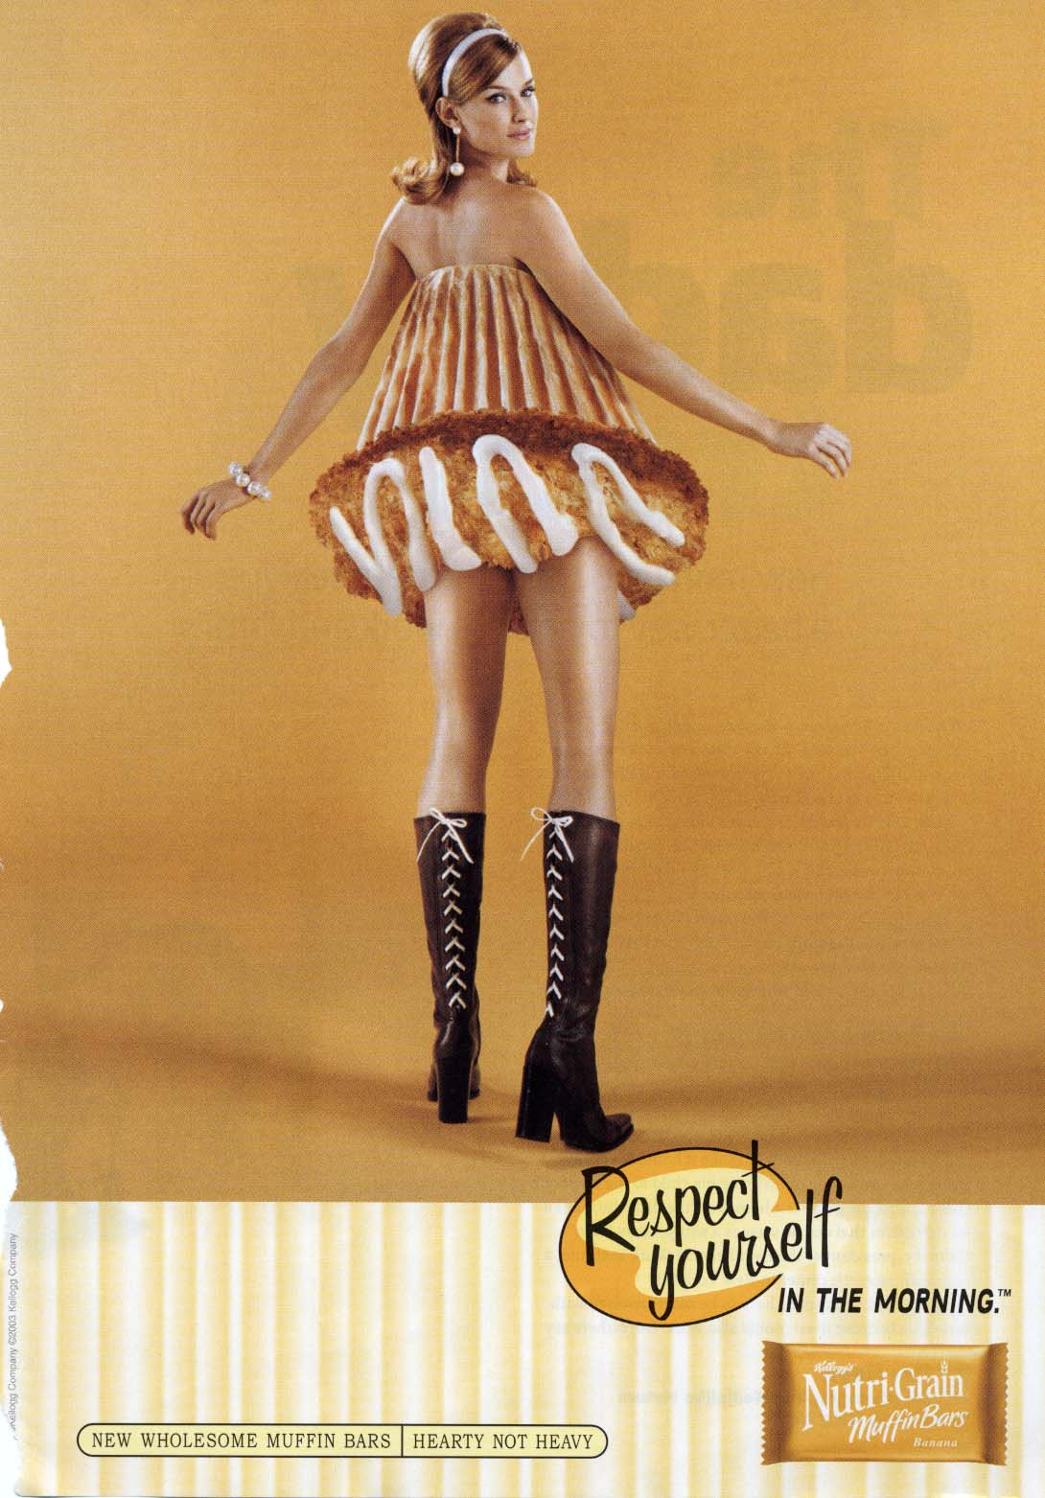
15. What is the brand problem? (one line)
Sales went down because cereal bar category got commoditized.

16. What is the consumer problem? (one line)
People with hectic morning routine tends to make bad food choices like eating donuts etc.
17. What is the insight for the consumer problem?
Hectic mornings make people more susceptible to poor food choices.
18. What is the positioning for this campaign?
Respect yourself in the morning.
19. What would be the communication strategy for this campaign (use Get–Who–To–By format)

GET: Breakfast Believers.
WHO: Are in hurry that their breakfast got reprioritized.
TO: Choose Nutri-Grain as their first choice in morning.
BY: Showing that Nutri-Grain can help them avoid the consequences of bad morning foods.

20. Name two brands your professor (Lee) worked on. (Hint: might want to check your syllabus)

- Pepsi
- CitiBank

